____________________________________________________

OSPF Area and LSA types

____________________________________________________

*Author*:

Gabriel Rosas



OSPF (Open Shortest Path First) is a routing protocol used in large enterprise networks due to it’s redundancy and efficiency. What makes OSPF so redundant is its ability to calculate backup routes if routers go down- in other words, there will always be a path allowing traffic to flow through a network. What makes OSPF so efficient is the time it takes to set up compared to manually configuring static routes.

So, what are my routing options and why should I prefer routing protocols? In networking, there are two options when dealing with traffic on a network; you can configure static routes, or you can set up a routing protocol. I like to think of static routes as absolute directions drawn onto a map, perhaps going through a forest. The directions are set in stone; the directions can’t be altered unless they are manually redrawn. Lets suppose you are following those directions by carriage through a forest but get stuck because there is a fallen tree or a broken bridge across a river. You are now lost and there is nowhere else to go. In this case, you, the packet, would get dropped. But now you’re in the same situation except this time a magical wizard constantly redraws the map to show new directions when older ones become unusable. Thus, is the magic of routing protocols- basically just google maps for packets. Ironically, both google maps and OSPF use the same algorithm for finding the best path, Dijkstra’s Algorithm.

Since we’ve defined what routing protocols are, I can go into more detail on how OSPF functions. Each router is like a junction for packets; packets usually have multiple roads they can turn down to reach further junctions, ultimately ending at their destination. Each router communicates with their neighboring routers to relay statuses and updates about themselves. If each router passes information about themselves and their neighbors to every other router, eventually all the routers will have complete knowledge of every direction to and from each other. In networking, having a table of directions to each destination is known as a routing table. All routers gain these directions by broadcasting their information to their neighbors. Via this process of broadcasting information, routers can get updates on what routes may or may not be viable to determine the best path from source to destination. These packets OSPF broadcasts to relay such information are known as **link-state advertisements** (LSAs). There are multiple types of LSA packets that each play a role in communication between OSPF routers. There are seven LSA types that I will cover.

**[Type 1: Router LSA]** – The router **announces its presence** in these packet types and lists the links to other routers or networks **in the same area**. Type 1 LSAs appear in their area only and can’t breach area border routers (ABR). The link state ID of type 1 LSAs is the router ID from the router who sent the LSA.

**[Type 2: Network LSA]** – If routers are joined on a multi-access network then the designated router (DR) will generate an LSA type 2 packet containing **the subnet of the broadcast segment**. For example, if four routers are each connected to a switch, this system becomes a broadcast segment. In a broadcast segment, a router will be designated to handle most of the updates between the other routers, saving bandwidth. It is noteworthy to know that this doesn’t occur in point-to-point connections. Type 2 LSAs are **generated by the DR** and appear in **their area only**. The link state ID for type 2 LSAs is the IP interface address of the DR.

**[Type 3: Summary LSA]** – Generated by the area border router (ABR), these LSAs **inform external areas about networks learned from an area**. Since the ABR generates LSA type 3 packets, they can be found within **other areas**. The link state ID for type 3 LSAs is the network address of the advertising router.

**[Type 4: ASBR Summary LSA]** – These LSA types **advertise the presence of an ASBR** (Autonomous System Border Router). Like ABRs, ASBRs have connections to other areas, but their primary purpose is to support external routes from another routing protocol. For example, an ASBR could have an interface in an OSPF area but also another interface running BGP, EIGRP, RIP, ext. Oddly enough, type 4 LSAs **aren’t** **broadcasted** in the area **with the ASBR**, instead they are **flooded to all other areas** with information containing **the routes to the ASBR**. The link state ID for a type 4 LSA is the ASBR router ID.

**[Type 5: ASBR External LSA]** – Generated by the ASBR, these LSAs **advertise the external routes connected to the ASBR**. For example, if an ASBR has an interface running BGP, it would advertise those external BGP routes. LSA type 5 packets are **flooded through all areas** once initially generated by an ASBR. The link state ID for a type 5 LSA is the external network number.

**[Type 6: Group Membership LSA]** – These packets were designed for multicast OSPF (MOSPF) but are not supported by CISCO and not widely used. MOSPF is deprecated as of OSPFv3 and isn’t widely used.

**[Type 7: Not so Stubby Area (NSSA) LSA]** – These LSAs are used in not so stubby areas that **block externally distributed routes** to save bandwidth. This means LSA type 5 packets are blocked or translated to LSA type 7 packets whilst in an NSSA since LSA type 5 packets contain external routes. Once the translated LSA type 7 packets pass through the NSSA and reach an ABR, they are passed into the next area and **retranslated** back to type 5 LSA packets.

Multiarea OSPF

OSPF routers communicate to each other using LSA packets, but this communication comes at a cost: bandwidth. If there was a large network, these LSA packets would begin to congest that network. So how do we limit the amount of LSA traffic on a network? The solution is to use **areas** to section of parts of the network into smaller groups.

Multiarea OSPF is the process of incorporating routers into multiple groups, “areas”, to reduce the size of the local topology (routing table) each router will store. The local topology is reduced due to **route summarization**, a process where multiple routes are combined into a **subnet**. “A router that needs to advertise ten routes needs ten specific lines in its update packet. The more routes you have to advertise, the bigger the packet. The bigger the packet, the more bandwidth the update takes, reducing the bandwidth available to transfer other data. But with route summarization, you can advertise many routes with only one line in an update packet” (Cisco Press). Creating summaries of each area reduces processing power, router memory and overall bandwidth of a network. 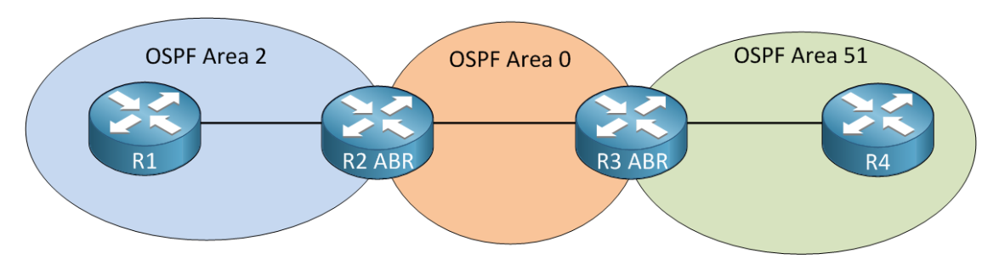

For example, in figure 1, there are three areas. Lets suppose router 1 is looking to send a packet to router 4. Router 1 doesn’t have the exact directions to where router 4 is, but it does have the directions to the subnet router 4 is on: through the interface connected to router 2. Router 2 doesn’t have a route with specific directions to the destination IP (router 4), but, like router 1, it does have the directions to the subnet router 4 is on, leading the packet to router 3. Router 3 is in the same area as router 4 so there’s a route directly to the IP of router 4 instead of just a subnet. The packet reaches router 4.

Specialized Areas

While having multiple areas might seem to solve lots of problems, there might still be bandwidth, processing power, and memory issues. If this occurs, configuring **specialized areas** is a great way to limit LSA traffic even further. There are three specialized area types that I will cover in this paper: stubby, totally stubby, and not so stubby (NSSA) areas.

**[LSA types found per area]**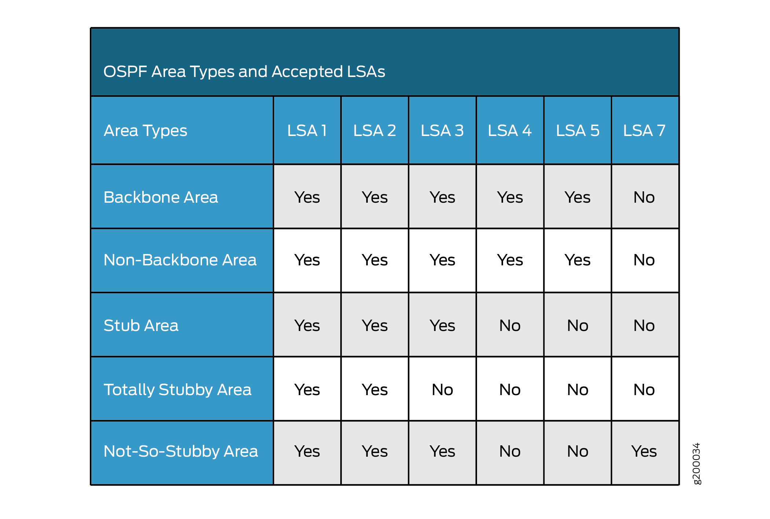

Totally Stubby Area

A Totally Stubby area was designed to have the least LSA traffic flooding around the area, with only two LSA types utilized: types 1 and 2. It was created to save the most bandwidth by **excluding all external routes** to shorten the routing table. All external routes are replaced by a **default route** since this area type depends on having only **one** exit out of the area. If a router has a packet destined for an IP it doesn’t know, the packet will be flooded out of the area to be dealt with somewhere else. Take, for example, a cul-de-sac: you wouldn’t need directions to get out of somewhere with only one way out.

Totally Stubby areas must only be connected to other areas with **a single ABR**. An ABR, not an ASBR. This is important because ASBRs generate both LSA type 4 and 5 traffic. Therefore, in not being connected to an ASBR, Totally Stubby areas don’t have to deal with either of these LSA types. Ultimately, Totally Stubby areas have the least LSA packet traffic but are the most situational depending on the size of the OSPF network.

Stub/Stubby Area

Stubby areas are like totally stubby areas, only stubby areas bend the rules slightly; these areas can be connected to **more than one ABR**. However, this does mean that LSA type 3 (summary) traffic is flooded throughout the area. Stub areas **still block external routes** like totally stubby areas- something that all three specialized areas have in common. While setting up default routes may be more complicated in this area due to multiple exit points, typically the best place to set default routes up is the ABR leading out towards the internet. Other ABRs in a stub area rely on route summary.

Stub areas are used since they retain smaller databases by excluding external routes, but still flood more LSA traffic than totally stubby areas.

Not so Stubby Area (NSSA)

Not so Stubby areas were designed for areas **containing an ASBR**. Like stub and totally stubby areas, NSSAs block external routes. When you think about it, the point of ASBRs are to advertise external routes, so how can an area containing an ASBR block external routes? NSSAs use type 7 LSA packets to camouflage the external route packets that ASBRs broadcast. Routers in the NSSA ignore these packets while they flood out of the NSSA. Once out of the NSSA, **type 7 LSAs are translated to type 5 LSAs** which contain the external routes of the ASBR.

By being connected to an ASBR and potential ABRs, an NSSA floods four LSA types throughout the area: types 1, 2, 3 and 7. NSSAs are a good choice to configure when dealing with an ASBR.